**DAILY ASSESSMENT FORMAT**

|  |  |  |  |
| --- | --- | --- | --- |
| **Date:** | **21/05/2020** | **Name:** | **Archana C J** |
| **Course:** | **TCS ION** | **USN:** | **4AL16EC007** |
| **Topic:** | **Learn Corporate Telephone**  **Etiquette**  **Understand Accounting**  **Fundamentals**  **Gain Foundational Skills in IT** | **Semester & Section:** | **8th - A** |
| **Github Repository:** | **Archana-c-j** |  |  |

|  |
| --- |
| **FORENOON SESSION DETAILS** |
| **Image of session** |

**Report –**

**Learn Corporate Telephone Etiquette**

In this online course on Learn Corporate Telephone Etiquette I learn that what we say, how much we say and how we say plays an important role in the impression we create on the listener. Through this module I learn important guidelines to be followed for effective corporate telephonic communication.

Throughout this course I learned following things–

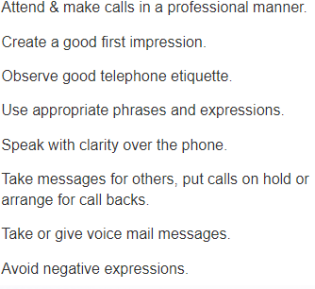

**Do’s of Telephone Etiquette**

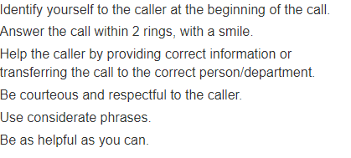

**Don’ts of Telephone Etiquette**

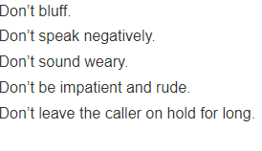

**Telephone Courtesies**

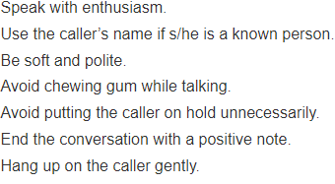

**Understand Accounting Fundamentals**

**Basics of Accounting –**

Accounting is the practice of recording and reporting on [business transactions](https://www.accountingtools.com/articles/2017/11/30/business-transaction).

System of record keeping - First, there must be a rational approach to record keeping. This means setting up [accounts](https://www.accountingtools.com/articles/2017/5/7/accounts) in which information is stored. Accounts fall into the following classifications:

* Assets - These are items purchased or acquired, but not immediately consumed. Examples are [accounts receivable](https://www.accountingtools.com/articles/2017/5/7/accounts-receivable) and [inventory](https://www.accountingtools.com/articles/2017/5/13/inventory).
* Liabilities - These are obligations of the business, to be paid at a later date. Examples are [accounts payable](https://www.accountingtools.com/articles/2017/5/5/accounts-payable) and [loans payable](https://www.accountingtools.com/articles/2017/5/9/loan-payable).
* Equity- This is assets minus liabilities, and represents the ownership interest of the owners of the business.
* Revenue- This is the amount billed to customers in exchange for the delivery of goods or provision of services.
* Expenses- This is the amount of assets consumed during the measurement period. Examples are rent expense and wages expense.

**Gain Foundational Skills in IT**

Foundational skills are the fundamental, portable skills that are essential to conveying and receiving information that is critical to training and workplace success. These skills are fundamental in that they serve as a basis - the foundation for supporting additional operations/tasks and learning. Reading a manual, listening to instructions, writing a memo, and working well in a team are all examples of using foundational skills on the job. Foundational skills are important across a wide variety of jobs, both skilled and professional. They are also necessary to learn more job-specific knowledge and skills. This is true across a wide variety of skilled and professional jobs.

The bottom line is that the importance of foundational skills will only increase. Educators and employers must work together to ensure that workers are prepared for the jobs of today and tomorrow that will keep our nation competitive in the global marketplace.

**DAILY ASSESSMENT FORMAT**

|  |  |  |  |
| --- | --- | --- | --- |
| **Date:** | **21/05/2020** | **Name:** | **Archana C J** |
| **Course:** | **Python** | **USN:** | **4AL16EC007** |
| **Topic:** | **Project Exercise with Python**  **and MySQL: Interactive**  **English Dictionary**  **Data Analysis with Pandas** | **Semester & Section:** | **8th - A** |
| **Github Repository:** | **Archana-c-j** |  |  |

|  |
| --- |
| **AFTERNOON SESSION DETAILS** |
| **Image of session** |

**Report –**

**Project Exercise with Python and MySQL: InteractiveEnglish Dictionary**

**Introduction to the App & Making of the App –**

**Code:**

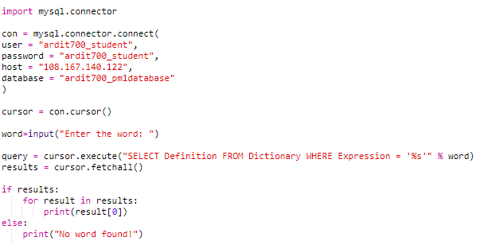

**Output –**

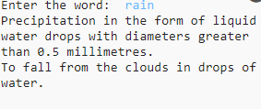

In the example we used the following SQL statement in our Python code:

query = cursor.execute ("SELECT * FROM Dictionary WHERE Expression = 'rain'")

This statement retrieved all the rows of the Dictionary table where the value of the column Expression was rain. The string inside cursor.execute () is SQL code that Python sends to the database. That kind of language is understood by the database.

**Data Analysis with Pandas–**

Installing Pandas

Make sure you have pandas installed. You can install it with pip:

pip install pandasorpip3 install pandas

Also, in the next lecture, we will use an enhanced Python interactive shell called IPython.IPython is just like the normal shell you get when you run python, but IPython provides better printing for large text. This ability makes IPython suitable for data analysis because the program prints data in a well-structured format. You can install IPython with pip:

pip install ipython orpip3 install ipython

**Loading JSON Files**

In the previous lecture you learned that you can load a CSV file with this code:

1. import pandas
2. df1 = pandas.read_csv("supermarkets.csv")

Try loading the supermarkets.json file for this exercise using read_json instead of read_csv.

The supermarkets.json file can be found inside the supermarkets.zip file attached in the previous lecture*.*

The code for loading the supermarkets.json file in Python with pandas would be this:

1. import pandas
2. df2 = pandas.read_json("supermarkets.json")

The df2 data frame should contain this data:

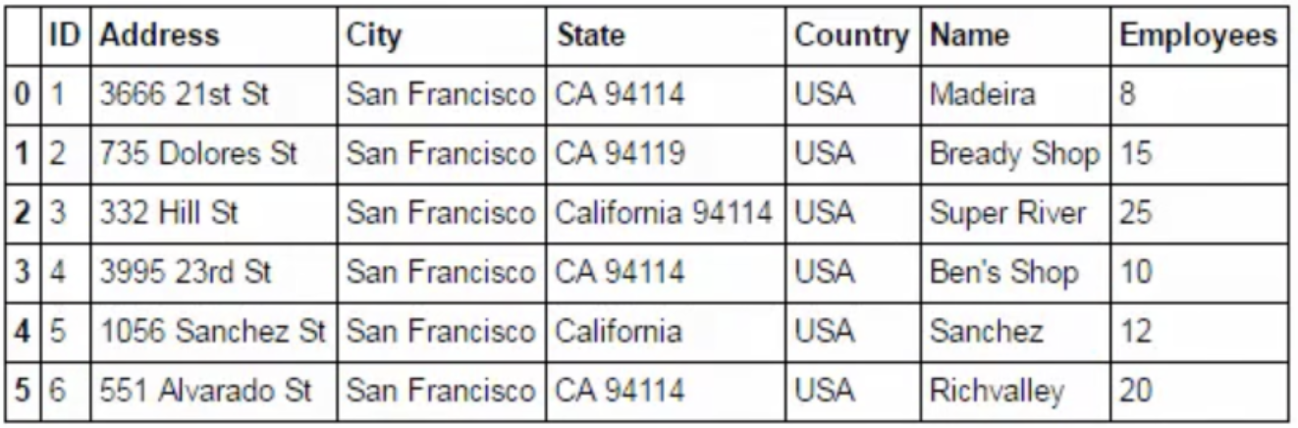

**Loading Excel Files**

To load Excel (.xlsx) files in Python with pandas. Pandas may require the xlrd library as a dependency. If you get an error such as ModuleNotFoundError: No module named 'xlrd', you can fix the error by installing xlrd:pip install xlrd orpip3 install xlrd

**Geopy -**

Geopy makes it easy for Python developers to locate the coordinates of addresses, cities, countries, and landmarks across the globe using third-party geocoders and other data sources.

Geopy includes geocoder classes for the [OpenStreetMap Nominatim](https://nominatim.org/), [Google Geocoding API (V3)](https://developers.google.com/maps/documentation/geocoding/), and many other geocoding services. The full list is available on the [Geocoders doc section](https://geopy.readthedocs.io/en/latest/#geocoders). Geocoder classes are located in [geopy. Geocoders](https://github.com/geopy/geopy/tree/master/geopy/geocoders).